Hani mohamed hassan
Assignment day 2

Part A
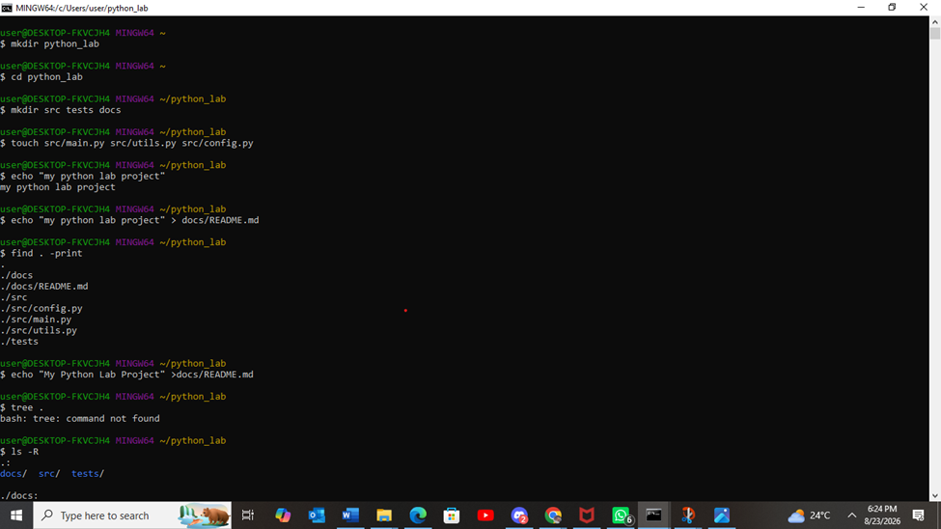
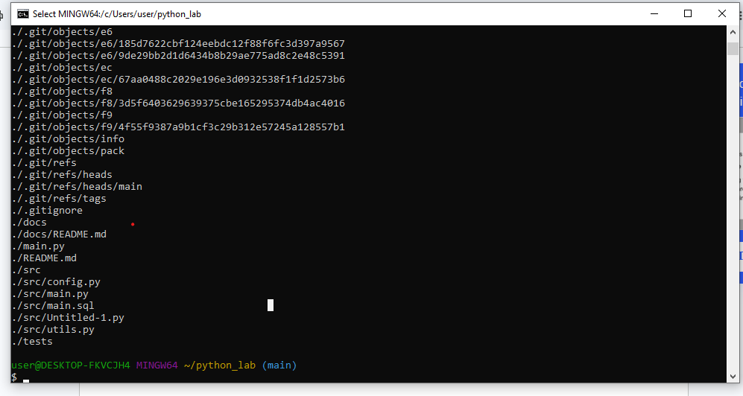
Paragraph 0ne
The mkdir command creates directories, and the cd command moves into a directory. I used these commands to create and enter the python_lab project folder. I then used mkdir to create the src, tests, and docs directories. The touch command created the empty Python files main.py, utils.py, and config.py. I used echo "My Python Lab Project" > docs/README.md to create the README file and write the required text using output redirection. Finally, I used find . to display the complete directory structure recursively
Paragraph two
Separating code into "src", tests into "tests", and documentation into "docs" is good software engineering practice because it keeps a project organized. The "src" folder contains the source code, the "tests" folder is used to check that the code works correctly, and the "docs" folder contains project information. This organization makes a project easier to understand, maintain, test, and expand, even when the project is small.

Part b
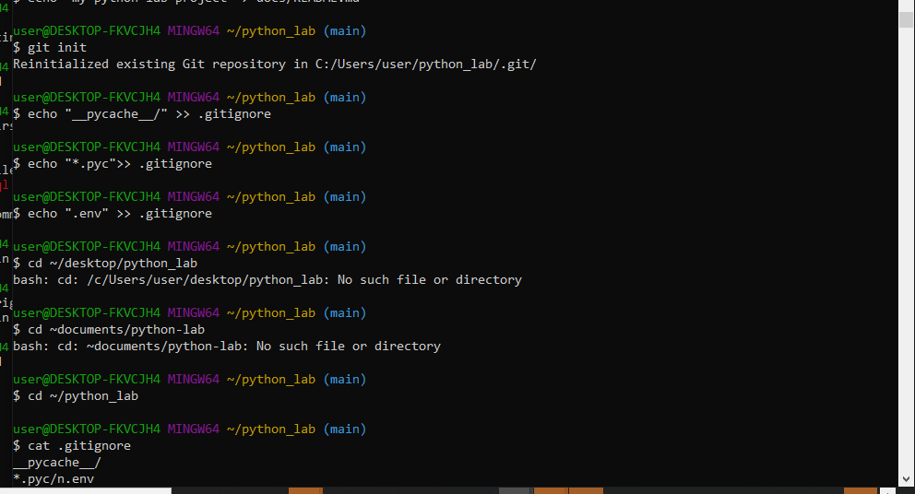
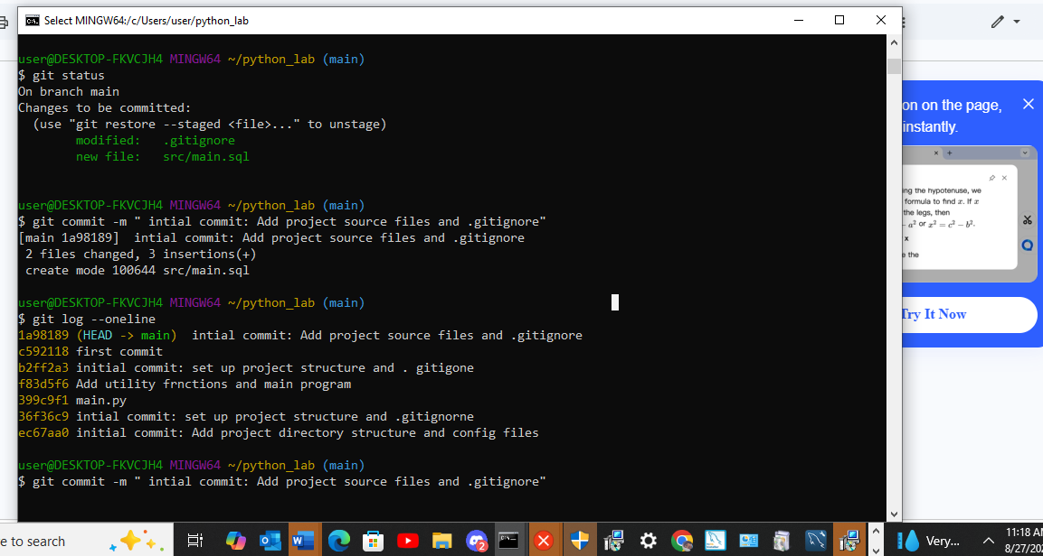
What .gitignore does:
A .gitignore file specifies intentionally untracked files and directories that Git should ignore. It prevents unnecessary, sensitive, or auto-generated build files from being staged, committed, or pushed to a remote version control repository like GitHub.
​2. Why the three specified file patterns matter:
​_pycache_/: Ignores the directories created automatically by Python to store bytecode. Committing these creates unnecessary repository clutter and clutter across different operating systems.
​*.pyc: Ignores individual compiled Python bytecode files. These are platform-dependent artifacts generated during execution that should not be shared or tracked in version control.
​.env: Ignores local environment variable files that typically contain sensitive application configurations, database credentials, or secret API keys. Keeping this file out of Git prevents accidental credential leaks.
​3. What the commit history reveals about a project's development over time:
The commit history acts as an immutable log of a project's evolution. It records who made changes, when those changes occurred, what specific code modifications were introduced, and why they were made (via the commit messages). Over time, it reveals the project's architecture trajectory, features added, bug fixes applied, and enables developers to audit code or revert to previous working states.
Part c
utils.py
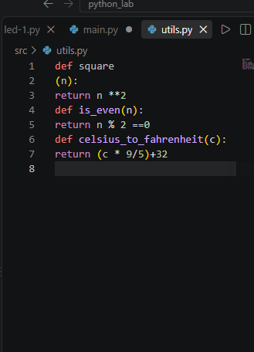
main.py
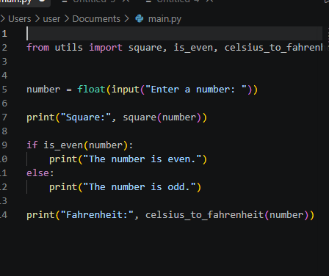
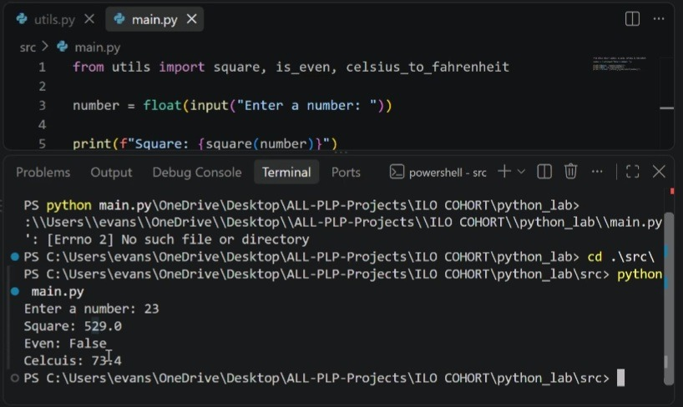
Explanation of the import system
You can explain it like this:
Python's import system allows one Python file to use functions from another Python file. In this project, main.py uses from utils import square, is_even, celsius_to_fahrenheit to import the three functions from utils.py. This allows main.py to call those functions without writing the same code again.
Test 1: Input = 5
Square: 25.0
The number is odd.
Fahrenheit: 41.0

Test 2: Input = 10
Square: 100.0
The number is even.
Fahrenheit: 50.0

Test 3: Input = 20
Square: 404.0
The number is even.
Fahrenheit: 68.0

PART D

